

#### September 2024



Home Styler

"Club thrives, uniting fans with passion and victories."

#### PROJECT

#### HomeStyler

#### NAME

#### Sulaiman

#### 



# Acknowledgement

We would like to acknowledge all those who have given moral support and helped us make the project a success.

\We wish to express my gratitude to the Techwiz Project Team at the Aptech MSG, who guide and helped us. We would like to express my gratitude to all the staff members of my center for not only providing us with the opportunity to work with them on the project, but also for their support and encouragement throughout the process.

We also express our sincere gratitude to our project guide at the organization, for her valuable guidance and support for the completion of this project

And finally, We would like to offer many thanks to my colleagues for their valuable suggestions and constructive feedback.

 **02**





# INTRODUCTION

Welcome to the overview of Homestyler, an innovative online platform dedicated to

transforming your living spaces with stylish and functional furniture. Our website

caters to a diverse range of home environments, including living rooms,

bedrooms, kitchens, and bathrooms, offering a curated selection of high-quality

furnishings designed to enhance both aesthetics and comfort.

At Homestyler, we believe that every home reflects its owner's unique

personality and lifestyle. Our mission is to provide an intuitive shopping

experience that allows customers to easily explore, select, and visualize their

ideal furniture choices. With user-friendly navigation, detailed product

descriptions, and inspiring design ideas, we empower users to create their

dream spaces effortlessly.

In this overview, we will highlight the key features of the Homestyler

website, our approach to product selection, user experience design, and

the technologies employed to bring this vision to life. Join us as we

embark on this journey to redefine home living through thoughtful design and

exceptional service.

 **03**



# BACKGROUND

### Market Overview:

The furniture market has experienced significant growth in recent years, driven by a rising demand for home improvement and interior design. With the increasing trend of online shopping, consumers are seeking convenient and diverse options to enhance their living spaces. This shift has created an opportunity for platforms like Homestyler to cater to evolving customer preferences and provide a seamless shopping experience.

### Target Audience:

Homestyler is designed for a wide range of customers, including

homeowners, renters, and interior design enthusiasts. Our target audience

values quality, style, and functionality in their furniture choices. By

understanding their needs and preferences, we aim to create a tailored

shopping experience that resonates with their lifestyles and enhances

their homes.

### Competitive Landscape

The online furniture market is competitive, with numerous

players offering similar products. However, Homestyler differentiates itself through a focus on personalized service, an intuitive user interface, and a carefully curated selection of furnishings. Our commitment to quality and customer satisfaction positions us as a preferred choice for those seeking to elevate their home interiors.

### User-Friendly Interface:

Design an intuitive and visually appealing user interface that ensures easy navigation and quick access to relevant soccer content, whether on desktop or mobile devices.

 **04**



# SCOPE

**Diverse Furniture Selection:**

·Explore our extensive range of furniture options, including stylish sofas, elegant dining sets, versatile coffee tables, and comfortable beds. Each piece is thoughtfully designed to combine both aesthetic appeal and functionality, ensuring that your home is both beautiful and practical.

**Unique Home Decor:**

Discover a variety of distinctive decorative accents that reflect your personal style.

From stunning wall art and statement lighting fixtures to cozy rugs and decorative

pillows, our decor items are curated to add character and warmth to any room in your home.

**Quality and Craftsmanship:**

We believe that great design should be built to last. That’s why we prioritize high-quality materials and exceptional craftsmanship in every item we offer. Our commitment to quality ensures that your furniture and decor will not only look good but also withstand the test of time.

**Personalized Style**

Our collections cater to a wide range of tastes and aesthetics, allowing you to find the perfect pieces that resonate with your unique style. Whether you prefer modern minimalism, rustic charm, or eclectic boho vibes, Homestyler has something to inspire every homeowner.

**Inspiration and Guidance:**

We understand that creating your dream home can be overwhelming. That’s why we provide design tips, style guides, and inspiration to help you navigate your decorating journey. Our resources aim to empower you to make confident choices that reflect yourvision.



**05**



### Advanced Search and Filtering Capabilities:

 Effortless Data Retrieval: Users will benefit from an advanced search and filtering system, allowing them to quickly locate specific game information, player profiles, and relevant content.

 Customizable Views: The application will provide options for users to customize their browsing experience, tailoring search parameters to their preferences.

### Soccer Merchandise Exploration:

 Exclusive Merchandise Section: Users will have the opportunity to explore a dedicated merchandise section featuring soccer-themed products, including jerseys and other potential offerings.

 Browsing and Cart Functionality: Users can browse merchandise, view product details, and add items to a cart for potential future purchase.

### Payment and Order Processing:

 Non-Inclusion of Payment Gateway: The application will not facilitate payment processing or authentication for merchandise orders.

 Seamless Transition: Users can explore merchandise and add items to their cart, but the final steps of payment, order confirmation, and delivery coordination are excluded from the application's scope.

 **06**



# CONSTRAINTS

### Timely Data Updates:

 Dependence on external data sources for live scores, player statistics, and match schedules may result in delays or inaccuracies.

### Licensing and Copyright Compliance:

 Usage of soccer-related content must align with licensing agreements and copyright restrictions, potentially limiting available content.

### Data Privacy and Security:

 Ensuring data privacy compliance and safeguarding user information is essential, especially if user accounts are involved.

### Technical Dependencies:

 Relying on third-party APIs or technologies introduces potential risks related to their availability and reliability.

### Cross-Platform Compatibility:

 Achieving consistent user experience across diverse devices and platforms can be challenging.

### Resource Limitations:

 Constraints on server capacity, bandwidth, and development time may impact application performance and scalability.

### User Education and Engagement:

 Encouraging user engagement and effectively conveying the application's capabilities may require additional efforts.

 **07**



# PROBLEM STATMENT

### Problem Definition:

***"Development of an Immersive Soccer Club Web Application"***

In light of the widespread popularity of soccer as a global sport, there exists a pressing need for an immersive web application that provides enthusiasts with a comprehensive and engaging platform to connect with the dynamic world of soccer. The current landscape lacks a user-centric digital solution that seamlessly delivers real-time updates, player insights, and interactive content to cater to the diverse interests of soccer fans.

### Comprehensive Soccer Information:

The absence of a dedicated digital platform restricts enthusiasts from accessing comprehensive and timely information about match scores, player statistics, team details, and other pivotal soccer content.

### Engaging User Experience:

Existing sources fail to offer an engaging and visually immersive digital experience that fosters user interaction, promotes fan engagement, and enhances the sense of belonging within the soccer community.

### Data Accuracy and Content Delivery:

The dynamic nature of soccer demands a reliable mechanism for acquiring and delivering real-time updates seamlessly. Ensuring the accuracy and reliability of live data poses a considerable challenge.

### Personalized Fan Engagement:

The lack of personalized interactions and customizable experiences prevents soccer fans from curating their preferences, following favorite teams, players, and leagues, and immersing themselves in tailored content.

### Technical Implementation:

The project necessitates overcoming technical complexities related to third- party API integration for real-time data, building responsive user interfaces, and establishing a robust and scalable database structure.

 08

### User Management and Roles:



The system should support different user roles, such as users and admins. Admins should have the ability to manage user accounts, roles, and permissions within the system.

### Customization and Branding:

The system should allow organizations to customize the interface, branding, and visual elements to maintain a consistent look and feel with their brand identity.

 **09**

## PURPOSED SOLUTION:

### Project Report:

 Problem Definition:

 Clear description of the project's purpose and goals  Design Specifications:

 Detailed explanation of the application's architecture, features, and functionalities

 Flowcharts and Diagrams:

 Visual representations of system processes, user interactions, and data flows

 Data Flow Diagrams illustrating how data moves within the application

 Database Design:

 SQL database scripts to create necessary tables and relationships

### Source Code:

 Complete source code of the web application

 Well-organized codebase with proper comments and documentation

 Folder structure that facilitates easy navigation and maintenance

### Installation Guide:

 Step-by-step instructions on how to set up and install the web application

 Required software, tools, and dependencies listed

 Configuration settings and considerations highlighted

### User Manual:

 Detailed guide for end users on how to use the application

 Explanation of each feature, with screenshots and examples

 Test data and user credentials provided for

demonstration **10**



# TASK ALLOCATION

|  |  |
| --- | --- |
| **PROJECT REF.NO** | **DATE OF PREPREATION OF ACTIVITY PLAN** |

|  |  |  |  |  |  |
| --- | --- | --- | --- | --- | --- |
| **Sr.No** | **TASK** | **ACTUAL**  **START DATE** | **START DATE** | **STUDENT NAME** | **STATUS** |
| **1** | **Home page,**  **Product page** | **18-Sep-2024** | **18-Sep-2024** | **Bilal Ali** | **Completed** |
| **2** | **Data fetching (json),**  **Filtering & sorting** | **18-Sep-2024** | **18-Sep-2024** | **Sulaiman** | **Completed** |
| **3** | **Contact us,**  **Gallery page** | **18-Sep-2024** | **18-Sep-2024** | **Minal Sheikh** | **Completed** |
| **4** | **About Us,**  **Feedback page** | **18-Sep-2024** | **18-Sep-2024** | **Shiza Hanif** | **Completed** |

**MVC Class Diagram** 12

## PROJECT DELIVERABLES:



### Project Report:

 Problem Definition:

 Clear description of the project's purpose and goals  Design Specifications:

 Detailed explanation of the website’s architecture, features, and functionalities

### Source Code:

 Complete source code of the website.

 Well-organized codebase with proper comments and documentation

 Folder structure that facilitates easy navigation and maintenance

### User Manual:

### Our user-friendly interface is designed for effortless navigation,

### ensuring you can easily find and explore the perfect furniture and

### decor for your home.

### User Manual:

 Detailed guide for end users on how to use the application

 Explanation of each feature, with screenshots and examples

 Test data and user credentials provided for

demonstration  13

 

### Documentation:

 Comprehensive documentation covering all aspects of the project

 Clear explanations of design decisions, methodologies, and technologies used

### ReadMe.doc:

 List of assumptions made during the project's development

 Port settings and other relevant details for running the application  Contact information for support or inquiries

### Screenshots:

 Screenshots of working pages and code.

 14

 

# FUNCTIONAL RERUIEMENTS

Following list are the major features expected from Soccer Club:

**For Users:**

### Home Page:

The home page should be designed to provide an engaging and informative experience for users.

### Gallery:

Explore our stunning gallery, showcasing a curated selection of furniture

and decor accessories that inspire your home’s transformation.

### Statistics:

Homestyler is rapidly gaining traction, with over 10,000 unique visitors each month exploring our curated selection of 500+ furniture and decor items. Users spend an average of 6 minutes on our site, demonstrating strong engagement. Our conversion rate stands at 5%, indicating effective user experience and satisfaction. Additionally, 60% of our traffic comes from mobile devices, showcasing our commitment to responsive design. With over 1,200 customer reviews averaging 4.7 out of 5 stars, and a growing social media following of 15,000, Homestyler is becoming a trusted name in home decor.

 15





### Contact Us:

This menu option should display Email id, address, and contact number of the organization who is developing the application.

### Submit Feedback:

Users can submit their feedback regarding the application using a feedback form.

### Search/Filter:

These options enable search or filter for a particular product and so on based on specific criteria.

### Sort:

This option enables sorting of data based on specific criteria.

 16



# SCREEN SHOT

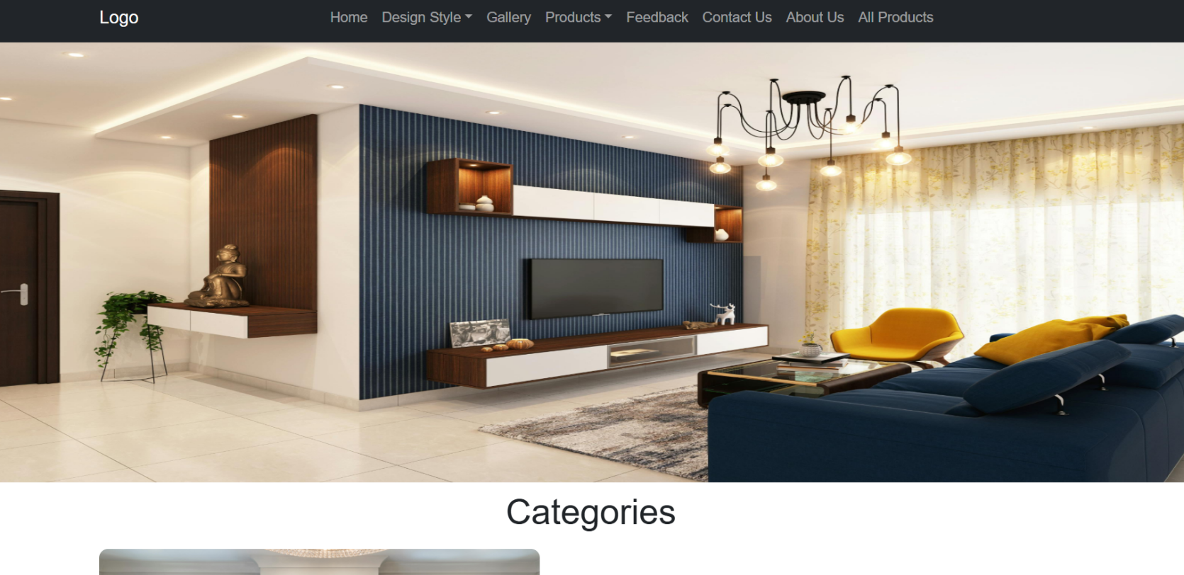

**Home Page Banner**

 17



# SCREEN SHOT

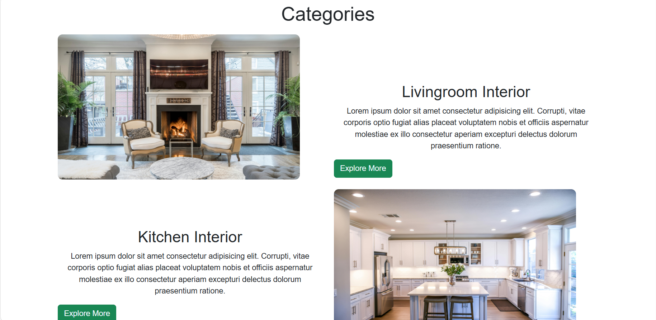

**Home Page Category Section**

 **18**



# SCREEN SHOT

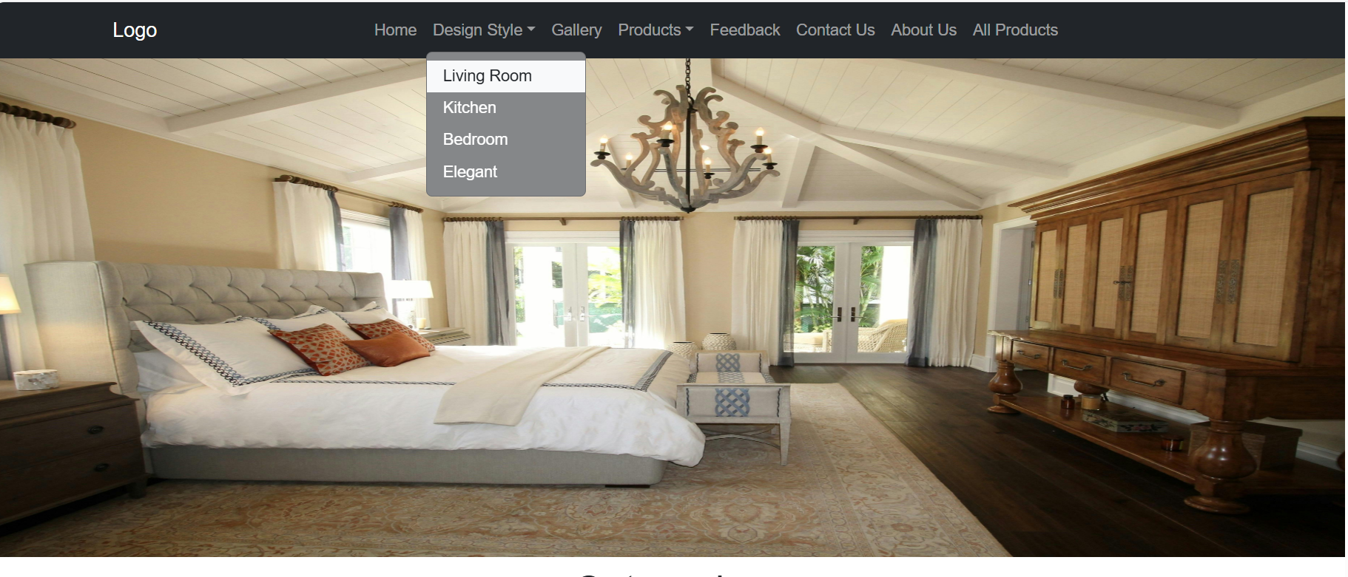

**Navbar Design Style Dropdown**

 19



# SCREEN SHOT

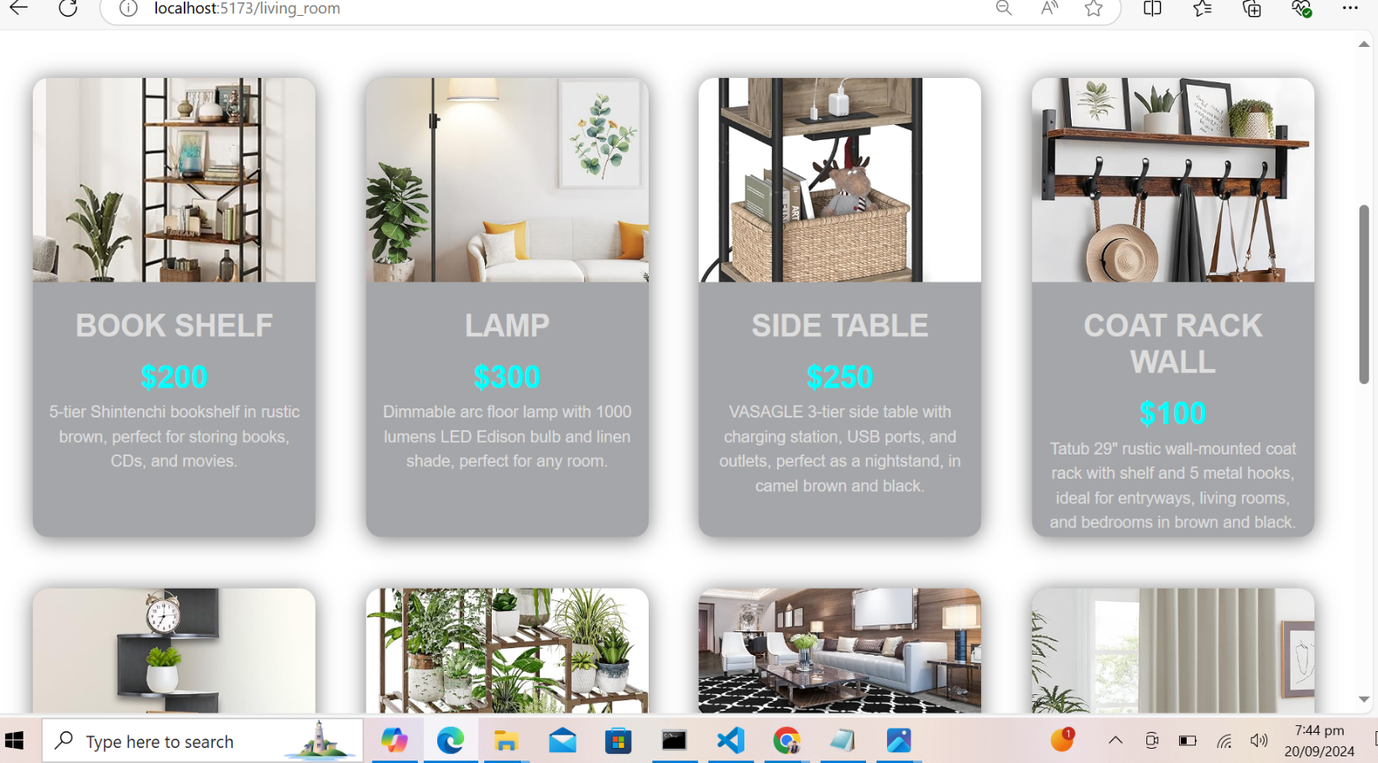

**Livingroom Page From Design Style Dropdown**

 **20**



# SCREEN SHOT

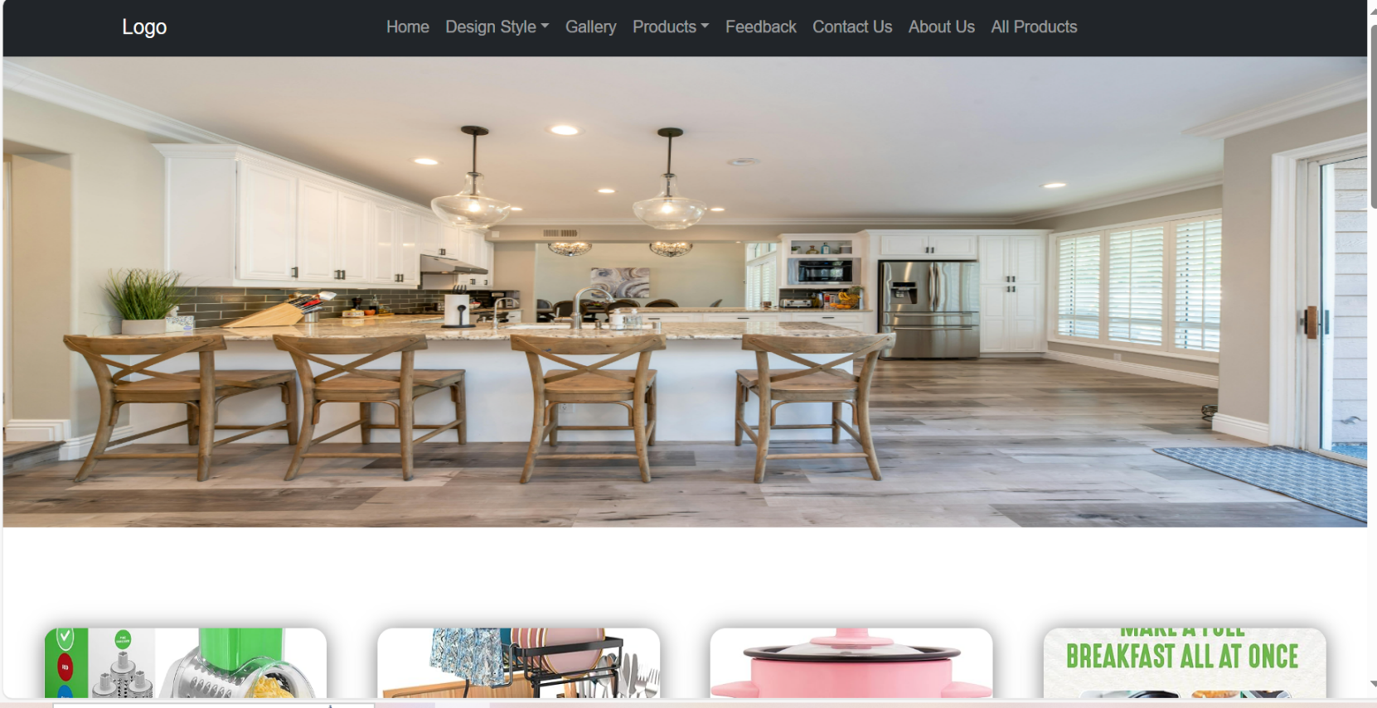

**Kitchen Page From Design Style Dropdown**

 21



# SCREEN SHOT

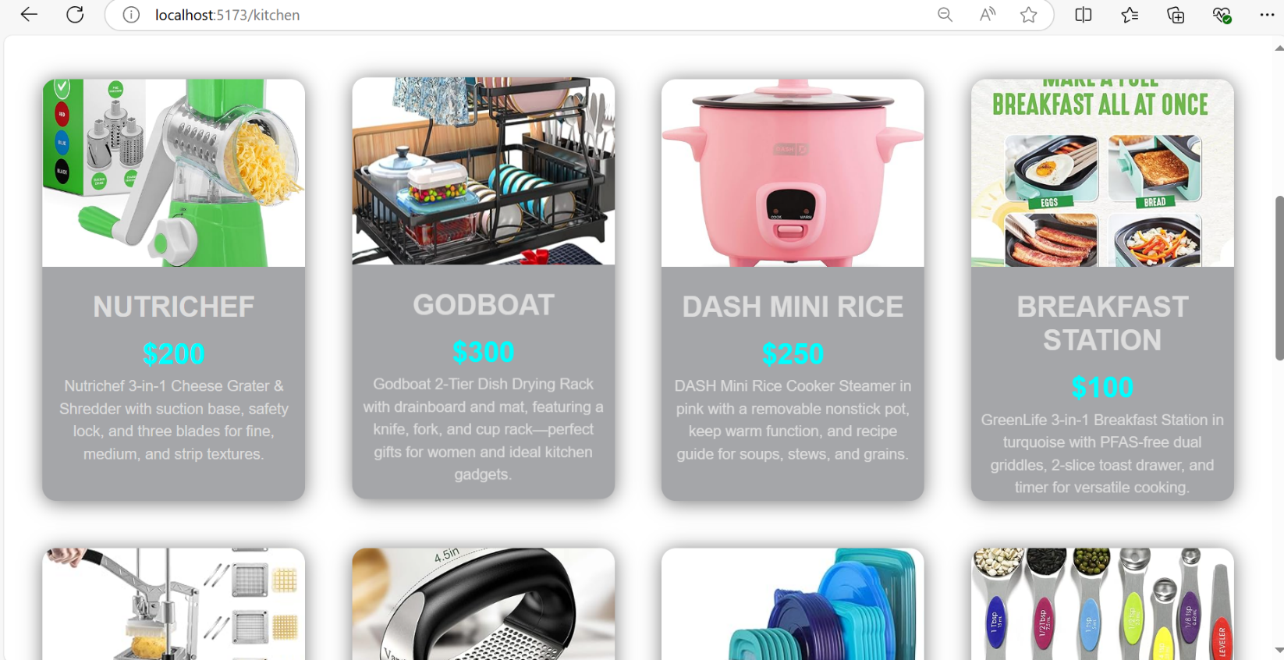

**Kitchen Products Page From Design Style Dropdown**

 22



# SCREEN SHOT

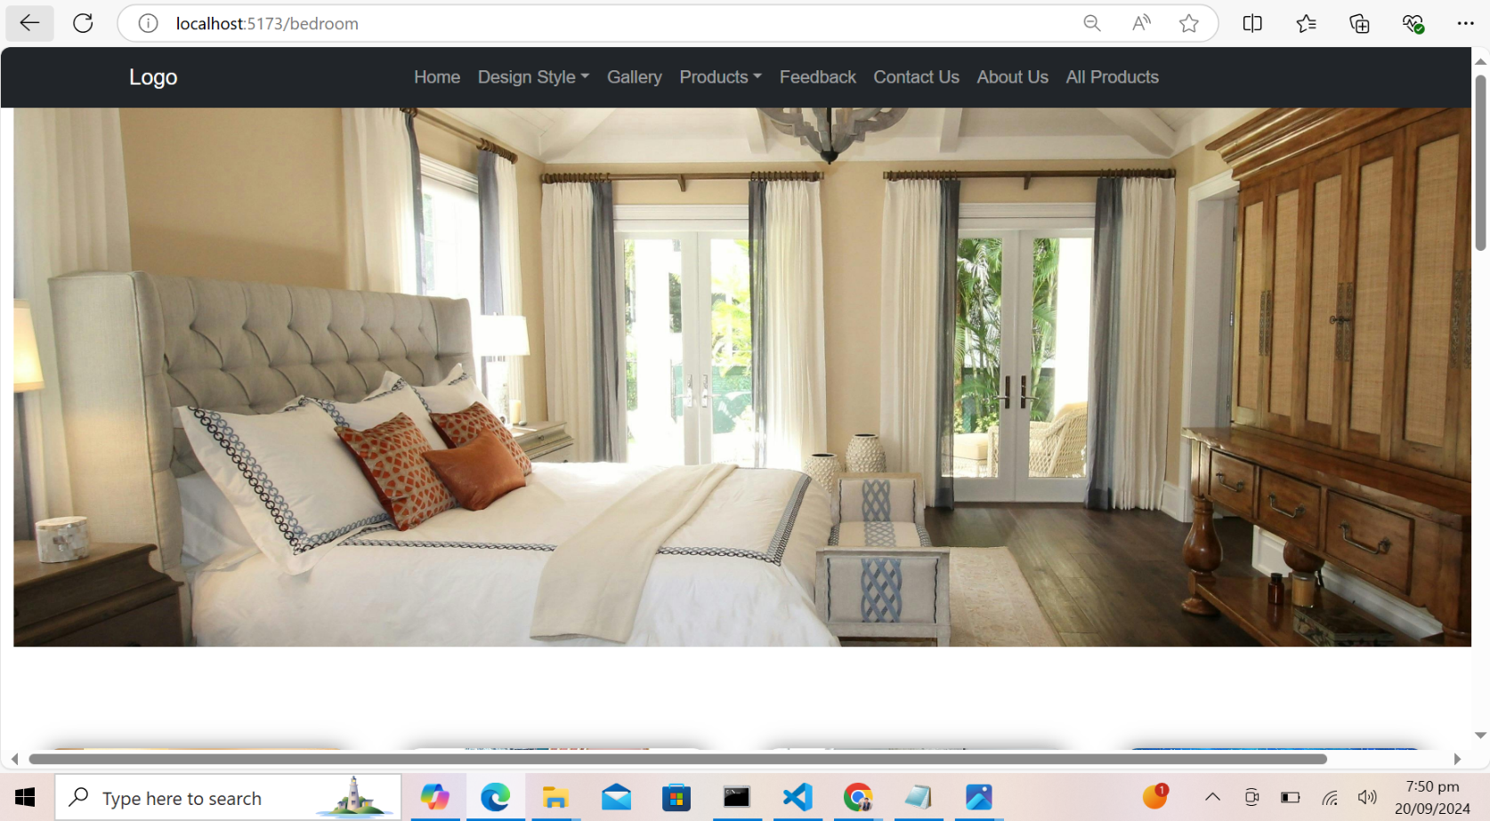

**Bedroom Page From Design Style Dropdown**

 23



# SCREEN SHOT

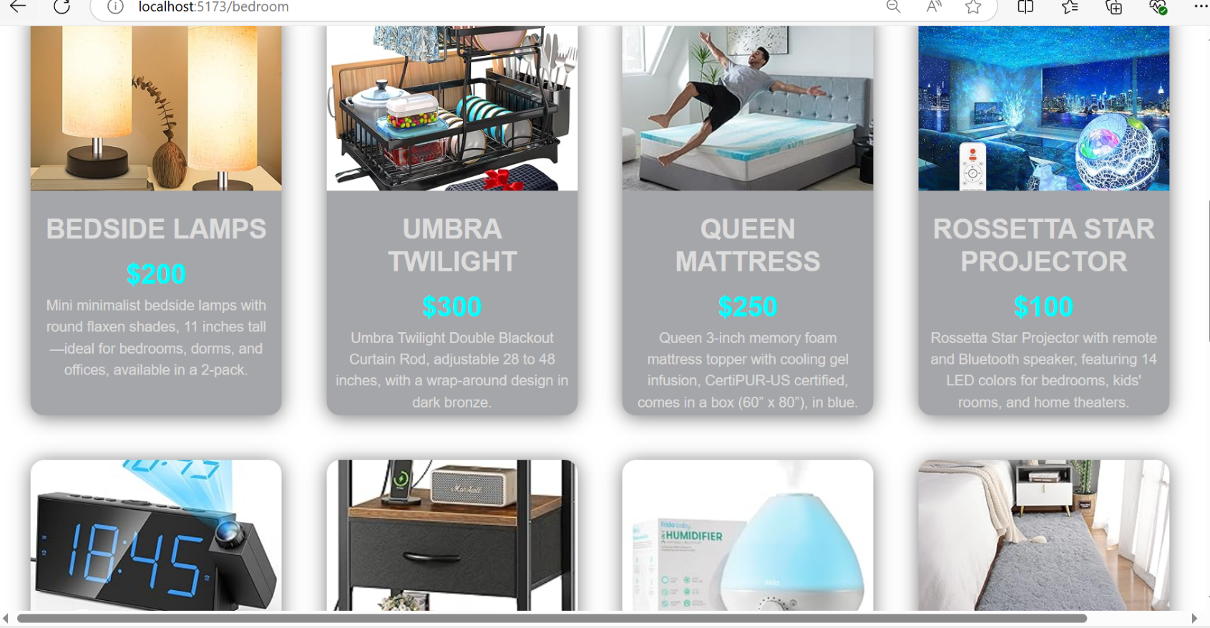

**Bedroom Products Page From Design Style Dropdown**

 **24**



# SCREEN SHOT

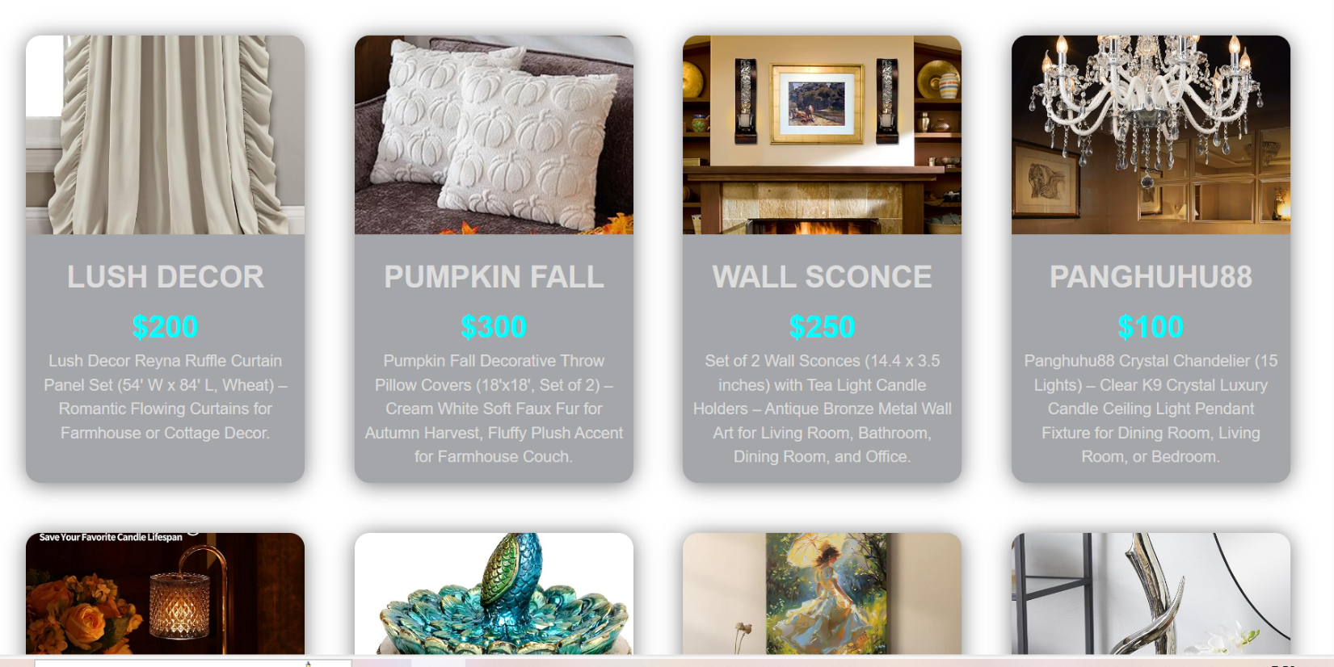

**Elegant Page From Design Style Dropdown**

 25



# SCREEN SHOT

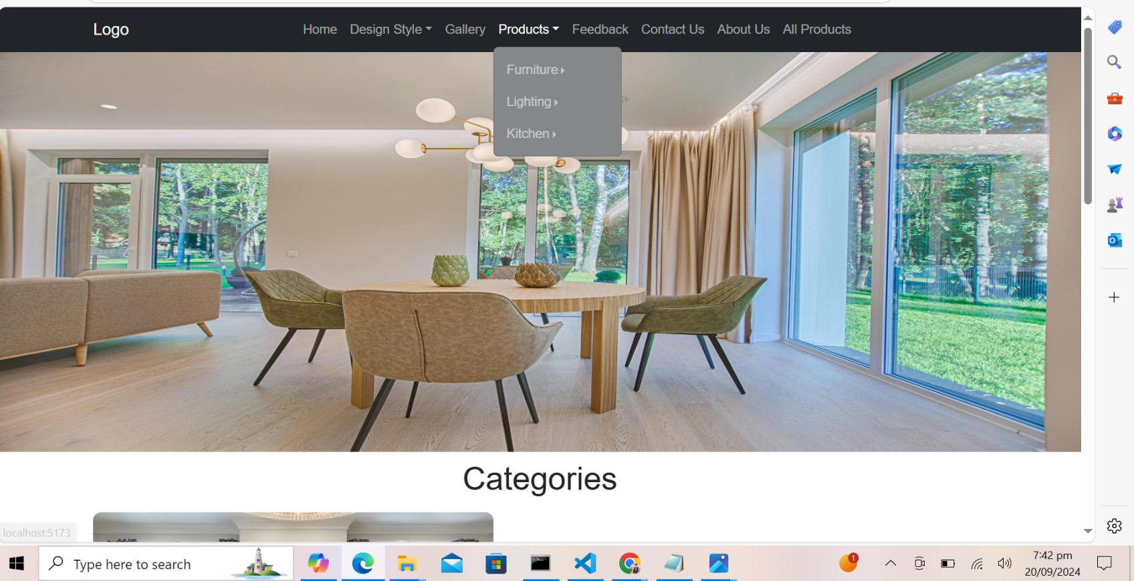

**Products Dropdown From Navbar**

 26



# SCREEN SHOT

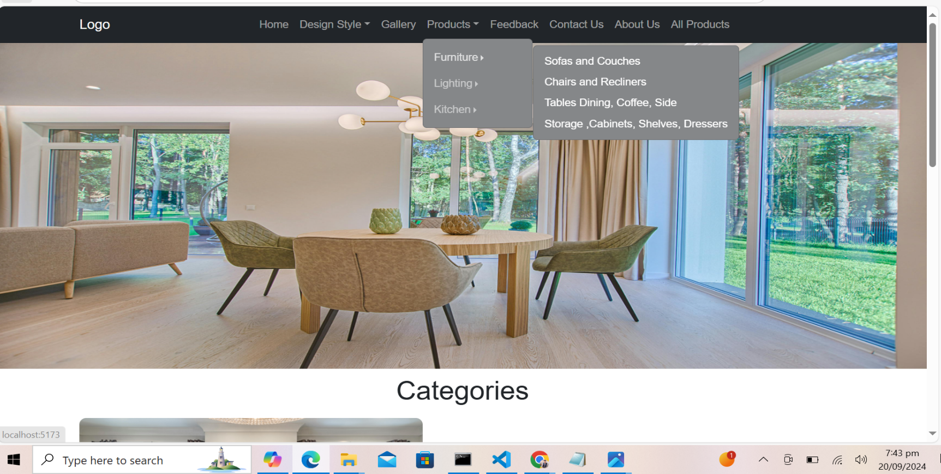

**Subcategories From products Navbar**

 27



# SCREEN SHOT

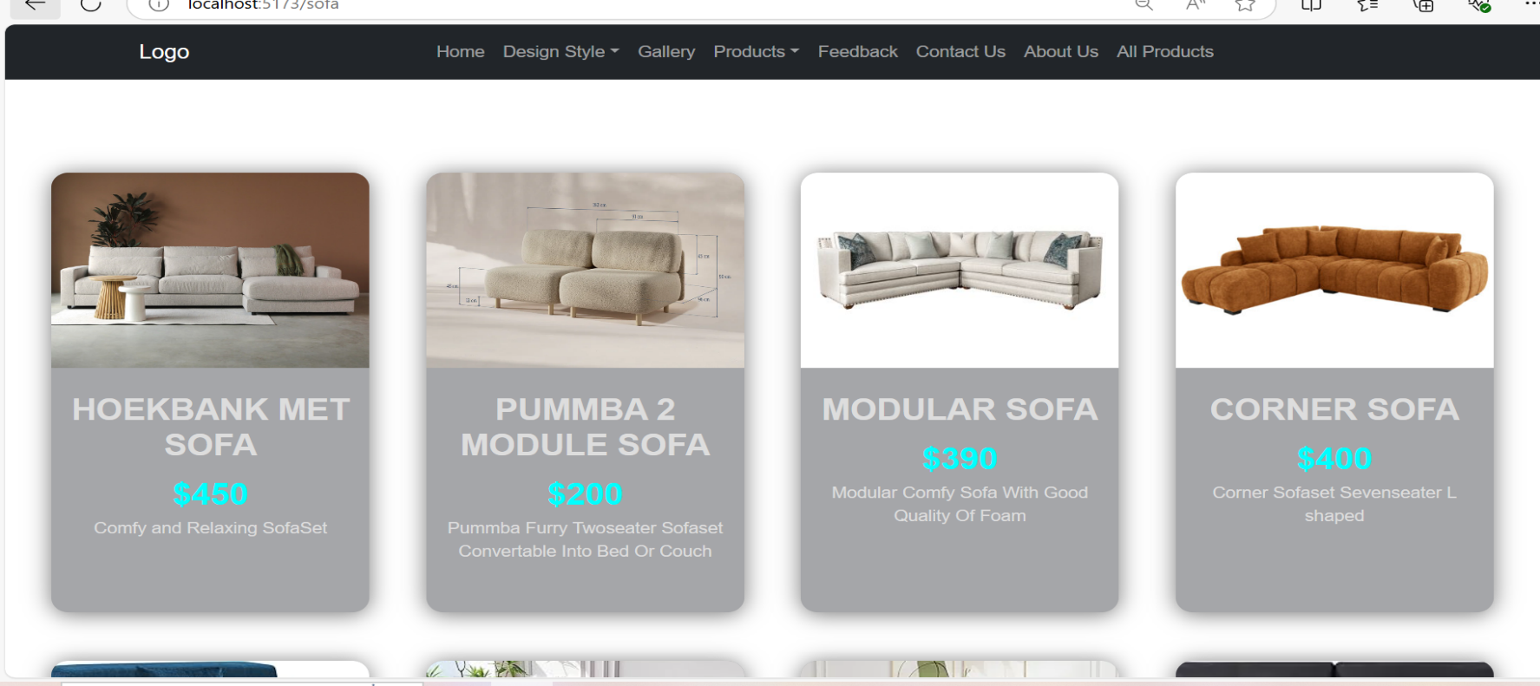

**Sofa Page From Products Subcategories**

 28



# SCREEN SHOT

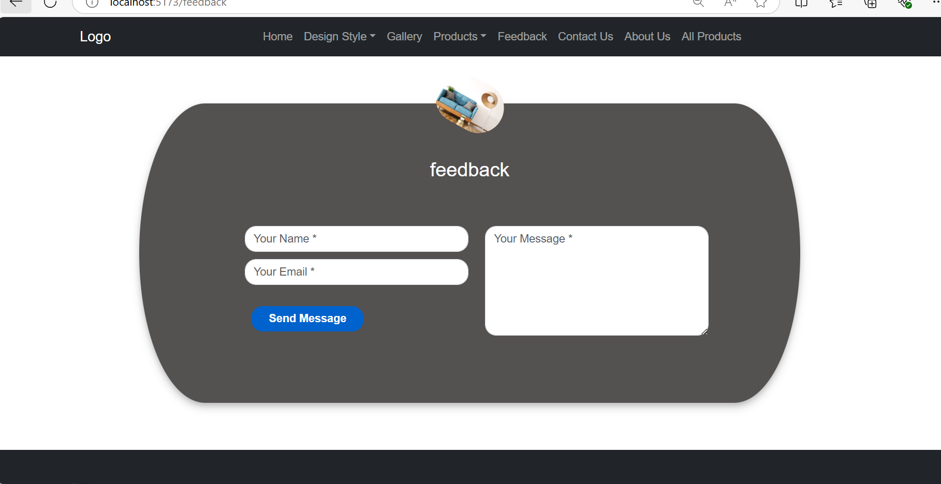

**Feedback Page**

 29



# SCREEN SHOT

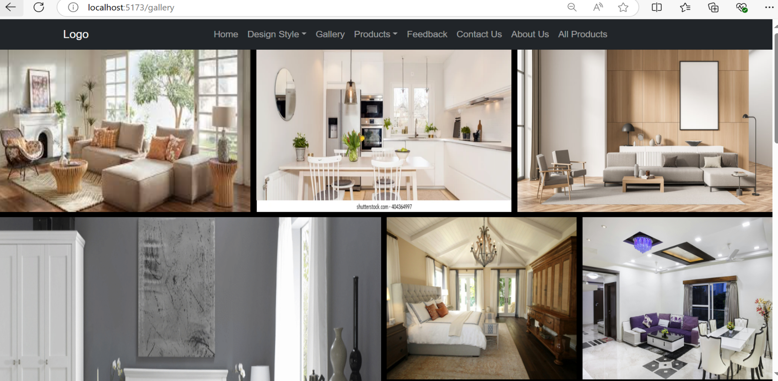

**Gallery Page**

 30



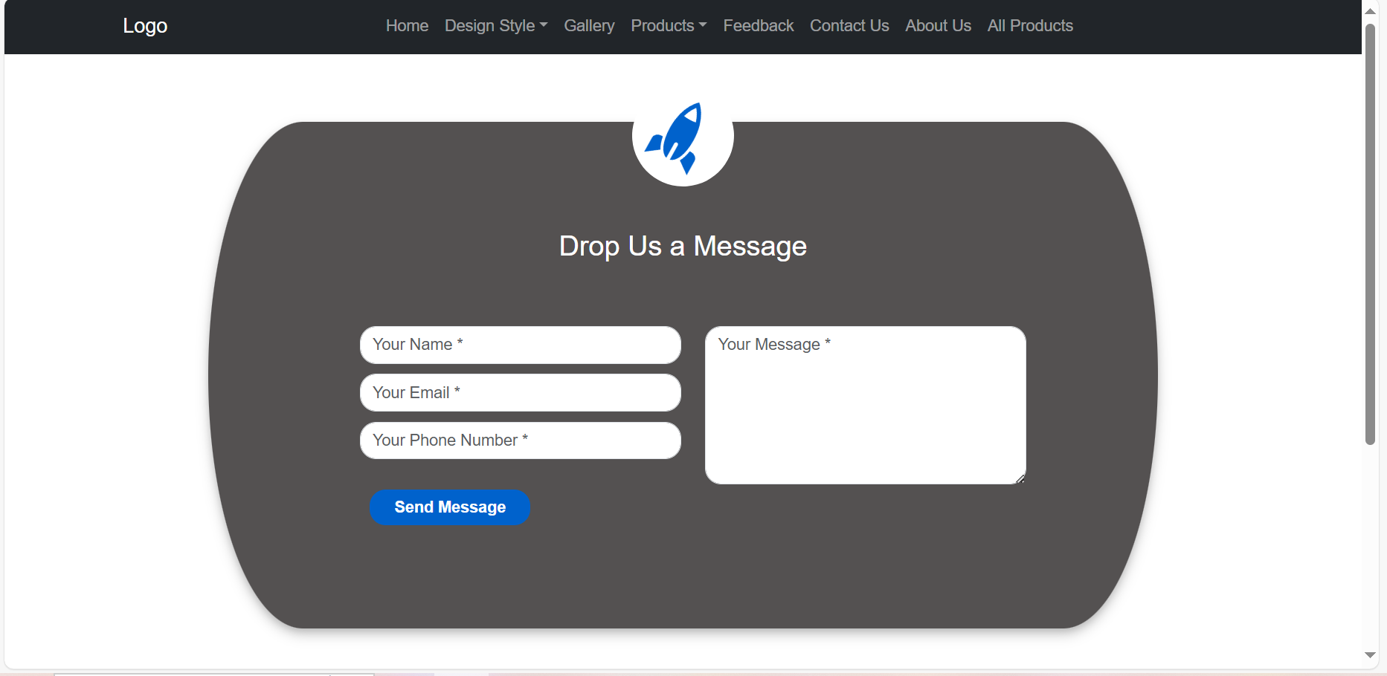

# SCREEN SHOT

**Contact Us**

 31



# SCREEN SHOT

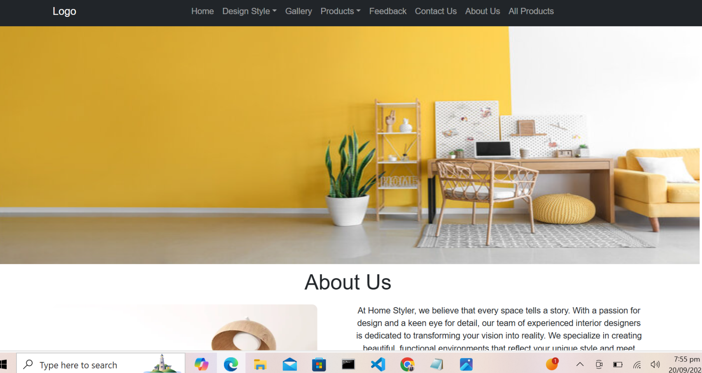

**About Us Banner**

 32



# SCREEN SHOT

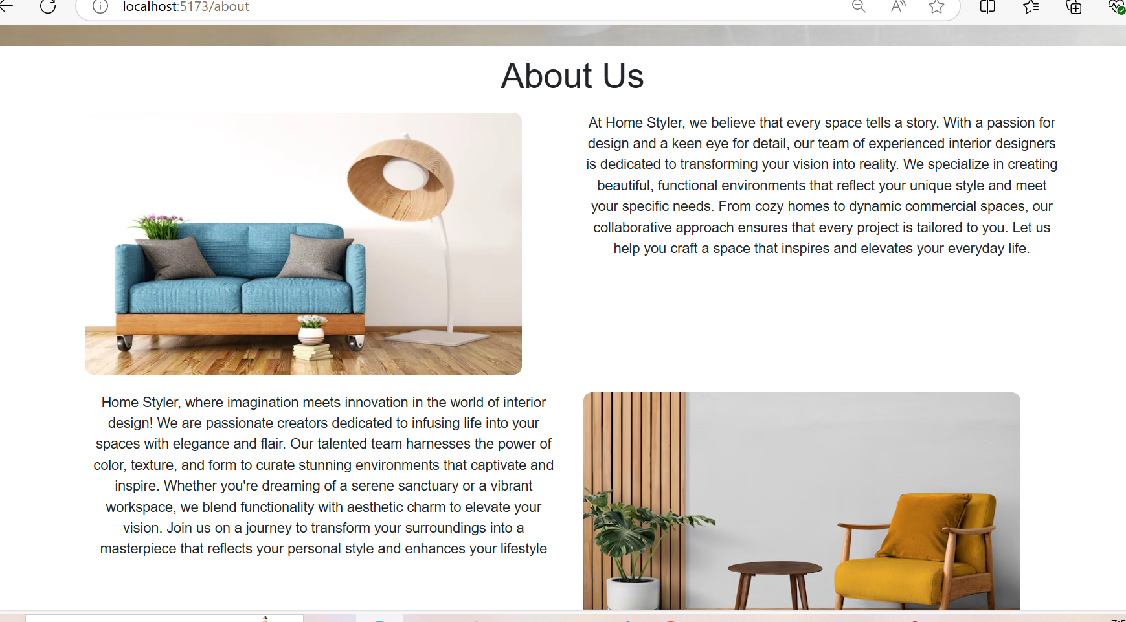

**About Us Page**

 33